Main content
Toolkit Part
C

Financial Analysis Tools
- C.1 Costs and Benefits
- C.2 Payback Analysis
- C.3 Return on Investment Analysis
- C.4 Present Value Analysis
- C.5 Summary
- Exercises
Change font size
help
Main content

C.1Costs and Benefits
A systems analyst must review a project’s costs and benefits at the end of each SDLC phase so management can decide whether or not to continue the project. Before the economic analysis tools described in this section of the Toolkit can be used, how to identify and classify all costs and benefits must be understood.
Cost-benefit analysis is the process of comparing the anticipated costs of an information system to the anticipated benefits. Cost-benefit analysis is performed throughout the SDLC to determine the economic feasibility of an information system project and to compare alternative solutions. Many cost-benefit analysis techniques exist. This Toolkit covers three of the most common methods: payback analysis, return on investment analysis, and present value analysis. Each of the approaches analyzes cost-benefit figures differently, but the objective is the same: to provide reliable information for making decisions.
As described in Chapter 2, economic feasibility means that the projected benefits of the proposed system outweigh the projected costs. When economic feasibility has been determined, the project’s benefits compared to the project’s total cost of ownership (TCO) must be considered, which includes ongoing support and maintenance costs, as well as acquisition costs.
Figure C-1 shows a TCO calculator to compare the costs of running applications on-premises or in the cloud using Amazon’s AWS infrastructure. Because migrating to the cloud is a complex activity, such calculators can greatly help the systems analyst make informed decisions. Google, IBM, Microsoft, and other vendors provide similar TCO guidance related to the cloud and other types of large-scale IT projects.
Figure C-1
Amazon offers a calculator to compare the TCO of running applications on-premises or in the cloud using AWS.
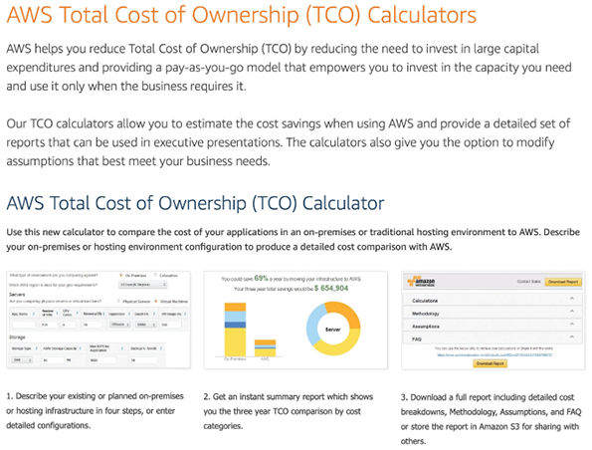
Source: Amazon Web Services, Inc.

C.1.1 Cost Classifications
Costs can be classified as tangible or intangible, direct or indirect, fixed or variable, and developmental or operational. As Chapter 2 explained, tangible costs are costs that can be assigned a specific dollar value. Examples of tangible costs include employee salaries, hardware and software purchases, and office supplies. Tangible costs also include the interest charges that firms must pay when they need to borrow money for working capital or to finance new projects. In times of high interest rates, these costs can be significant and must be considered.
In contrast, intangible costs are costs whose dollar value cannot be calculated easily. The cost of customer dissatisfaction, lower employee morale, and reduced information availability are examples of intangible costs.
If the analyst examines an intangible item carefully, however, it sometimes is possible to estimate a dollar value. For example, users might dislike a system because it is difficult to learn. Their dissatisfaction is an intangible cost, but if it translates into an increase in errors that must be corrected, a tangible dollar cost could be assigned. It is preferable to work with tangible costs whenever possible.
Direct costs are costs that can be associated with the development of a specific system. Examples of direct costs include the salaries of project team members and the purchase of hardware that is used only for the new system. In contrast, indirect costs, or overhead expenses, cannot be attributed to the development of a particular information system. The salaries of network administrators, copy machine rentals, and insurance expenses are examples of indirect costs.
Fixed costs are costs that are relatively constant and do not depend on a level of activity or effort. Many fixed costs recur regularly, such as salaries and hardware rental charges. Variable costs are costs that vary depending on the level of activity. The costs of printer paper, supplies, and telephone charges are examples of variable costs.
Developmental costs are incurred only once, at the time the system is developed or acquired. Those costs might include salaries of people involved in systems development, software purchases, initial user training, and the purchase of necessary hardware or furniture. Operational costs, covered in Chapter 12, are incurred after the system is implemented and continue while the system is in use. Examples of operational costs include system maintenance, ongoing training, annual software license fees, and communications expense.
Some costs apply to more than one category of expenses. For example, overtime pay for clerical staff during the systems analysis phase would be classified as developmental, variable, and direct. A monthly fee for maintaining the company’s website would be regarded as operational, fixed, and indirect.

C.1.2 Managing Information Systems Costs and Charges
Management wants to know how much an information system costs, so it is important for the systems analyst to understand direct costs, indirect costs, and methods of allocating IT charges within the company.
Direct costs usually are easier to identify and predict than indirect costs. For example, the salaries of project team members and the purchase of hardware, software, and supplies for the new system are direct costs. After a new information system goes into operation, other direct costs might include the lease of system-specific hardware or software.
Many IT department costs cannot be attributed directly to a specific information system or user group. Those indirect costs can include general hardware and software acquisition expenses, facility maintenance, air-conditioning, security, rent, insurance, and general supplies, and the salaries of operations, technical support, and information center personnel.
A chargeback method is a technique that uses accounting entries to allocate the indirect costs of running the IT department. Most organizations adopt one of four chargeback methods: no charge, a fixed charge, a variable charge based on resource usage, or a variable charge based on volume.
- No charge method. Some organizations treat information systems department indirect expenses as a necessary cost of doing business, and IT services are seen as benefiting the entire company. Thus, indirect IT department costs are treated as general organizational costs and are not charged to other departments. In this case, the information systems department is called a cost center because it generates accounting charges with no offsetting credits for IT services.
- Fixed charge method. With this method, the indirect IT costs are divided among all the other departments in the form of a fixed monthly charge. The monthly charge might be the same for all departments or based on a relatively constant factor such as department size or number of workstations. By using a fixed charge approach, all indirect costs are charged to other departments, and the IT group is regarded as a profit center. A profit center is a department that is expected to break even or show a profit. Under the profit center concept, company departments purchase services from the IT department and receive accounting charges that represent the cost of providing the services.
- Variable charge method based on resource usage. Resource allocation is the charging of indirect costs based on the resources used by an information system. The allocation might be based on connect time, server processing time, network resources required, printer use, or a combination of similar factors. Connect time is the total time that a user is connected actively to a remote server; some Internet service providers use this as a basis for charges. In a client/server system, server processing time is the time that the server actually responds to client requests for processing. The amount a particular department is charged will vary from month to month, depending not only on that department’s resource usage but also on the total resource usage. The IT department is considered a profit center when an organization uses the resource allocation method.
- Variable charge method based on volume. The indirect IT department costs are allocated to other departments based on user-oriented activity, such as the number of transactions or printing volume. As with the resource allocation method, a department’s share of the costs varies from month to month, depending on the level of activity. In this case, the IT department is considered a profit center.

C.1.3 Benefit Classifications
In addition to classifying costs, the benefits that the company expects from a project must be classified. Like costs, benefits can be classified as tangible or intangible, fixed or variable, and direct or indirect. Another useful benefit classification relates to the nature of the benefit: positive benefits versus cost-avoidance benefits. Positive benefits increase revenues, improve services, or otherwise contribute to the organization as a direct result of the new information system. Examples of positive benefits include improved information availability, greater flexibility, faster service to customers, higher employee morale, and better inventory management.
In contrast, cost-avoidance benefits refer to expenses that would be necessary if the new system were not installed. Examples of cost-avoidance benefits include handling the work with current staff instead of hiring additional people, not having to replace existing hardware or software, and avoiding problems that otherwise would be faced with the current system. Cost-avoidance benefits are just as important as positive benefits, and both types must be considered when performing cost-benefit analysis.
Change font size
help
Main content

C.2Payback Analysis
Payback analysis is the process of determining how long it takes an information system to pay for itself. The time it takes to recover the system’s cost is called the payback period. To perform a payback analysis, the following steps are executed:
- Determine the initial development cost of the system.
- Estimate annual benefits.
- Determine annual operating costs.
- Find the payback period by comparing total development and operating costs to the accumulated value of the benefits produced by the system.
When the system costs over the potential life of the system are plotted, typically there is a curve similar to the one shown in Figure C-2. After the system is operational, costs decrease rapidly and remain relatively low for a period of time. Eventually, as the system requires more maintenance, costs begin to increase. The period between the beginning of systems operation and the point when operational costs are rapidly increasing is called the economically useful life of the system.
Figure C-2
The costs of a typical system vary over time. At the beginning, system costs are high due to initial development expenses. Costs then drop during systems operation. Maintenance costs begin to increase until the system reaches the end of its economically useful life.
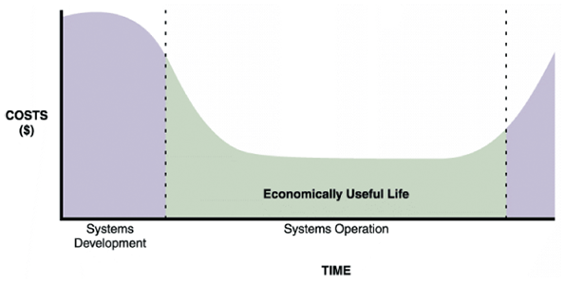
When the benefits provided by an information system are plotted against time, the resulting curve usually resembles the one shown in the upper graph in Figure C-3. Benefits start to appear when the system becomes operational, might increase for a time, and then level off or start to decline.
Figure C-3
Benefits of an information system change over time, as shown in the upper graph. The lower graph shows costs and benefits plotted on the same graph. The dashed line indicates the payback period, when accumulated benefits equal accumulated costs.
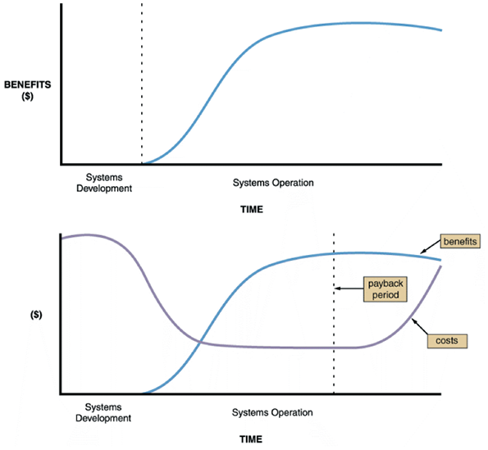
When conducting a payback analysis, the time it takes for the accumulated benefits of an information system to equal the accumulated costs of developing and operating the system are calculated.
In the lower graph in Figure C-3, the cost and benefit curves are plotted together. The dashed line indicates the payback period. Note that the payback period is not the point when current benefits equal current costs, where the two lines cross. Instead, the payback period compares accumulated costs and benefits. If current costs and benefits are graphed, the payback period corresponds to the time at which the areas under the two curves are equal.
Consider the example shown in Figure C-4, which contains two cost-benefit tables. The tables show the anticipated annual costs, cumulative costs, annual benefits, and cumulative benefits for two information systems projects. Year 0 (zero) corresponds to the year in which systems development begins. The development of Project A takes less than one year, so some benefits are realized in Year 0. Systems development for Project B requires more than one year, so the benefits do not begin until sometime in Year 1.
Figure C-4
Payback analysis data for two information systems: Project A and Project B.
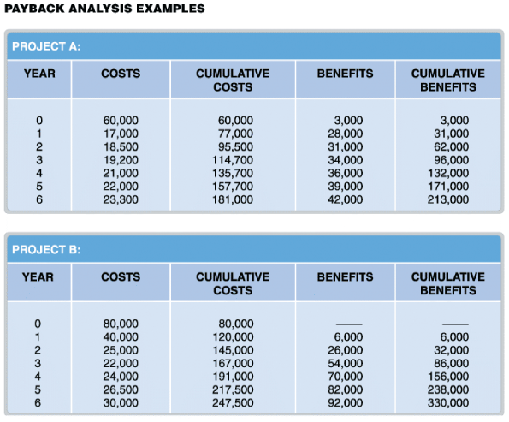
In Project A, by the end of Year 4, the cumulative costs are $135,700, which slightly exceeds the $132,000 cumulative benefits. By the end of Year 5, however, the cumulative benefits of $171,000 far exceed the cumulative costs, which are $157,700. Therefore, at some point in time during Year 5, the accumulated costs and benefits are equal, and the payback period is established. In Project B, a similar situation exists. By the end of Year 4, Project B’s cumulative costs are $191,000, which is greater than the cumulative benefits of $156,000. At some point during Year 5, cumulative benefits will exceed cumulative costs, and the system will have paid for itself.
If more specific information is available regarding the timing of costs and benefits during a year, the payback period can be calculated more precisely. Another approach is to create a chart that shows the exact point when cumulative benefits exceed cumulative costs, which is explained in Section C.2.1.
Some managers are critical of payback analysis because it places all the emphasis on early costs and benefits and ignores the benefits received after the payback period. Even if the benefits for Project B in Year 6 soared as high as $500,000, the payback period for that project still occurs during the fifth year of operation. In defense of payback analysis, the earlier cost and benefit predictions usually are more certain. In general, the further out in time that projections extend, the more uncertain the forecast will be. Thus, payback analysis uses the most reliable of cost and benefit estimates available.
Payback analysis rarely is used to compare or rank projects because later benefits are ignored. It should not be concluded that Project A is better than Project B simply because the payback period for A is less than that for B; considering all the costs and all the benefits when comparing projects makes more sense.
Even with its drawbacks, payback analysis is popular. Many business organizations establish a minimum payback period for approved projects. If company policy requires a project to begin paying for itself within three years, then neither project in Figure C-4 would be approved, though both are economically feasible because total benefits exceed total costs.

C.2.1 Using a Spreadsheet to Compute Payback Analysis
A spreadsheet can be used to record and calculate accumulated costs and benefits, as shown in Figure C-5. The first step is to design the worksheet and label the rows and columns. After entering the cost and benefit data for each year, the formulas are entered. For payback analysis, a formula is needed to display cumulative totals, year by year. For example, the first year in the cumulative costs column is the same as Year 0 costs, so the formula in cell C6 is =B6. The cumulative cost total for the second year is Year 0 cumulative total + Year 1 costs, so the formula for cell C7 is =C6+B7, and so on. The first worksheet shows the initial layout and the second worksheet shows the finished spreadsheet.
Figure C-5
A Microsoft Excel worksheet displays payback analysis data for Project A in the upper screen. When cumulative cost and benefit formulas are entered, the finished worksheet in the lower screen appears.
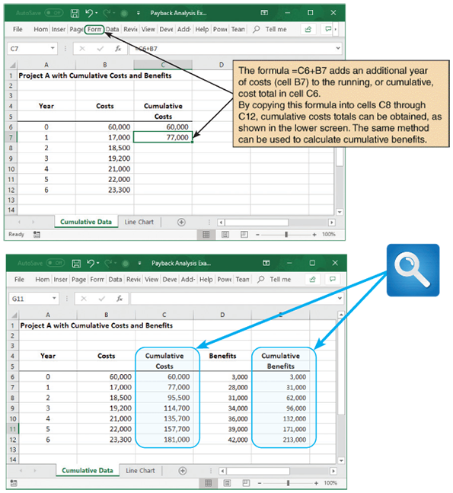
After verifying that the spreadsheet operates properly, a line chart is created that displays the cumulative costs, benefits, and payback period, which is identified by the intersection of the cost and benefit lines, as shown in Figure C-6.
Figure C-6
Microsoft Excel can be used to show the payback period by creating a chart of cumulative costs and benefits. Note that Project A has a shorter payback period than Project B.
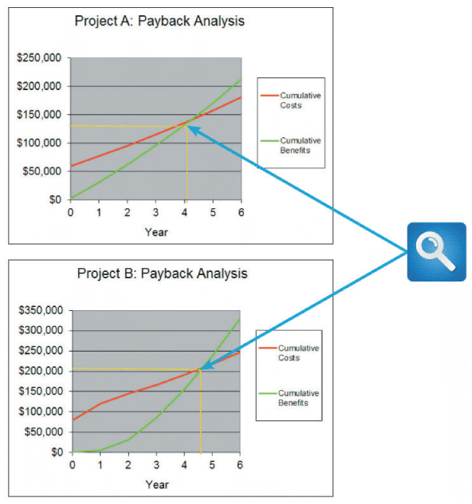
Change font size
help
Main content

C.3Return on Investment Analysis
Return on investment (ROI) is a percentage rate that measures profitability by comparing the total net benefits (the return) received from a project to the total costs (the investment) of the project. ROI is calculated as follows:
ROI analysis considers costs and benefits over a longer time span than payback analysis. ROI calculations usually are based on total costs and benefits for a period of five to seven years. For example, Figure C-7 shows the ROI calculations for Project A and Project B. The ROI for Project A is 17.7%, and the ROI for Project B is 33.3%.
Figure C-7
Return on investment analysis for Projects A and B shown in Figure C-4.
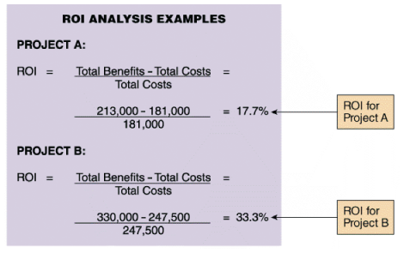
In many organizations, projects must meet or exceed a minimum ROI. This minimum ROI can be an estimate of the return the organization would receive from investing its money in other investment opportunities such as treasury bonds, or it can be a higher rate that the company requires for all new projects. If a company requires a minimum ROI of 15%, for example, then both Projects A and B would meet the criterion.
ROI can also be used for ranking projects. If Projects A and B represent two different proposed solutions for a single information systems project, then the solution represented by Project B is better than the Project A solution. If Projects A and B represent two different information systems projects, and if the organization has sufficient resources to pursue only one of the two projects, then Project B is the better choice.
Critics of ROI analysis raise two points. First, ROI measures the overall rate of return for the total period, and annual return rates can vary considerably. Two projects with the same ROI might not be equally desirable if the benefits of one project occur significantly earlier than the benefits of the other project. The second criticism is that the ROI technique ignores the timing of the costs and benefits. This concept is called the time value of money and is explained in Section C.4.

C.3.1 Using a Spreadsheet to Compute ROI
A spreadsheet can be used to calculate the ROI. To do so for Project A, first set up the worksheet and enter the cost and benefit data. Cumulative columns can be used (as was done for payback analysis), but two overall totals are also needed (one for costs and one for benefits), as shown in Figure C-8.
Figure C-8
Sample ROI worksheet. Note that cell E13 contains the ROI formula.
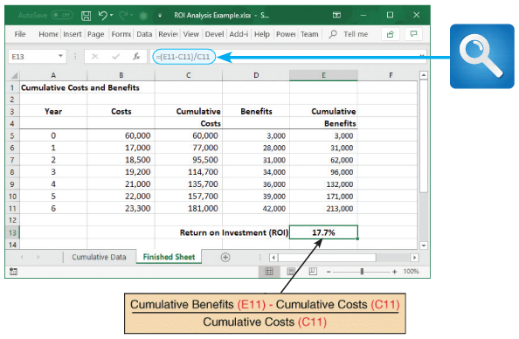
The last step is to add a formula to calculate the ROI percentage rate, which is displayed in cell E13 in Figure C-8. As stated previously, the ROI calculation is total benefits minus total costs, divided by total costs. Therefore, the formula that displays the ROI percentage in cell E13 is =(E11−C11)/C11.
A major advantage of using a spreadsheet is if the data changes, the worksheet can be modified, and a new result calculated instantly.
Change font size
help
Main content

C.4Present Value Analysis
A dollar today is worth more than a dollar received a year from today. A dollar in hand can be invested now and it will grow in value. For example, most people would rather have $100 right now rather than the promise of a dollar a year from now. If the $100 was invested today in a mutual fund that has an annual return of 8%, one year from now there would be $108 instead of $100.
ROI can also be approached from a different direction. For example, instead of asking, “How much will $100 be worth a year from now?” ask instead, “How much should be invested today, at 8%, in order to have $100 a year from now?” This concept is known as the time value of money, as shown in Figure C-9, and it is the basis of the technique called present value analysis.
Figure C-9
Portion of a present value table showing adjustment factors for various time periods and discount rates. Values in the table are calculated using the formula shown in the text. Note how the factors decrease as time and percentage increase.
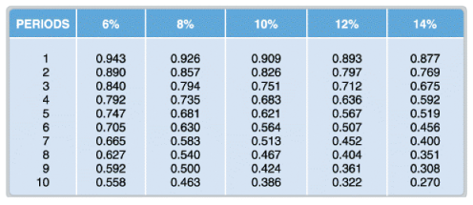
The present value of a future dollar is the amount of money that, when invested today at a specified interest rate, grows to exactly one dollar at a certain point in the future. The specified interest rate is called the discount rate. In present value analysis, a company uses a discount rate that represents the rate of return if the money is put into relatively risk-free investments, such as bonds, instead of being invested in the project.
Most companies require a rate of return that is higher than the discount rate because of the degree of risk in any project compared with investing in a bond. Companies often reject projects that seem attractive because the risk is not worth the potential reward.
To help the analyst perform present value analysis, adjustment factors for various interest rates and numbers of years are calculated and printed in tables called present value tables. Figure C-9 shows a portion of a present value table, including values for 10 years at various discount rates.
To use a present value table, locate the value in the column with the appropriate discount rate and the row for the appropriate number of years. For example, to calculate the present value of $1 at 12% for five years, look down the 12% column in Figure C-9 until reaching the row representing five years. The table value is 0.567. To determine what the present value of $3,000 will be in five years with a discount rate of 12%, multiply the present value factor from the table by the dollar amount; that is, .
Many finance and accounting books contain comprehensive present value tables. This information can be obtained on the Internet, as shown in Figure C-10.
Figure C-10
Many online sources contain comprehensive present value tables.
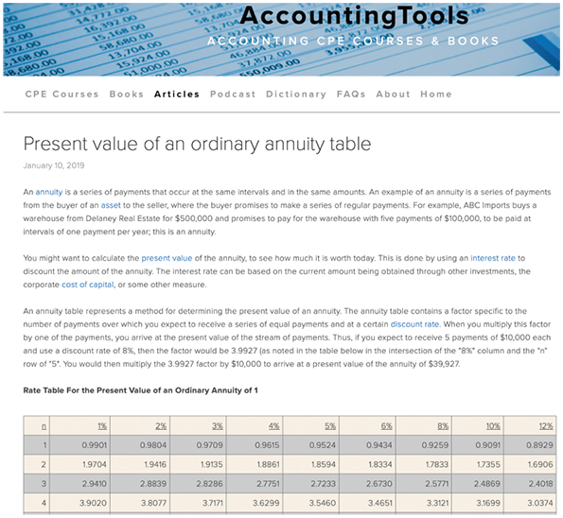
Source: AccountingTools
To perform present value analysis, the cost and benefit figures must be time-adjusted. First, multiply each of the projected benefits and costs by the proper present value factor, which depends on when the cost will be incurred or the benefit will be received. The second step is to sum all the time-adjusted benefits and time-adjusted costs. Then, calculate the net present value (NPV) of the project, which is the total present value of the benefits minus the total present value of the costs. Figure C-11 shows the calculation of NPV for two sample projects.
Figure C-11
Net present value analysis for Project A and Project B. The tables use discount factors from external sources, such as the CCH website shown in Figure C-10.
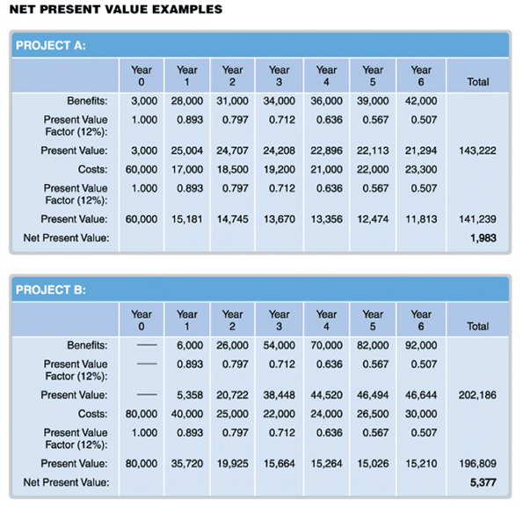
In theory, any project with a positive NPV is economically feasible because the project will produce a larger return than would be achieved by investing the same amount of money in a discount rate investment. Remember that risks are associated with any project, however, and management typically insists on a substantially higher return for high-risk projects. For example, both projects in Figure C-11 have positive NPVs and appear economically worthwhile.
Suppose, however, that it was known one of the projects had a 90% probability of achieving its goals, while the other project had only a 70% chance. To be attractive, the project with the higher risk would have to offer a corresponding higher reward. Chapter 3 explains how project managers evaluate risks.
NPV also can be used to compare and rank projects. All things being equal, the project with the highest NPV is the best investment. Figure C-11 shows that Project B is a better investment than Project A because it has a higher NPV.
Present value analysis provides solutions to the shortcomings of payback analysis and ROI analysis. Unlike payback analysis, present value analysis considers all the costs and benefits and not just the earlier values. In addition, present value analysis takes into account the timing of costs and benefits, so their values can be adjusted by the discount rate that provides a common yardstick and recognizes the time value of money. Even so, companies often use all three methods to get more input for making decisions. Sometimes a project will score higher on one method of analysis and lower on another.

C.4.1 Using a Spreadsheet to Calculate Present Value
There are two ways to calculate present value using a spreadsheet program such as Microsoft Excel. The discount adjustment factors can be entered from an external table, and a simple formula is used to apply the factors. However, many analysts find it easier to use a built-in NPV formula that handles the calculations. The two methods are described in the following sections. The example shows costs and benefits for a proposed information system with a one-year development period, a three-year useful life, and a 6% discount rate.

Using External Factors
The first method is to create a spreadsheet similar to Figure C-12. Starting with the estimated benefits, enter adjustment factors in cells C5, D5, and E5. Then create formulas in cells C6, D6, and E6 that multiply the three factors times the dollar amounts for each year, with a total shown in column F. The same thing is done for the estimated costs. Finally, when the total costs are subtracted from total benefits, the NPV for the proposed system displays in cell F12.
Figure C-12
The top screen shows how to use discount factors to calculate present value in a Microsoft Excel spreadsheet. In this case, the present value of benefits is $79,160. The bottom screen shows an example of the NPV function, which is a menu-driven formula that is built into Excel. The slight difference between the values is because Excel uses more decimal places.
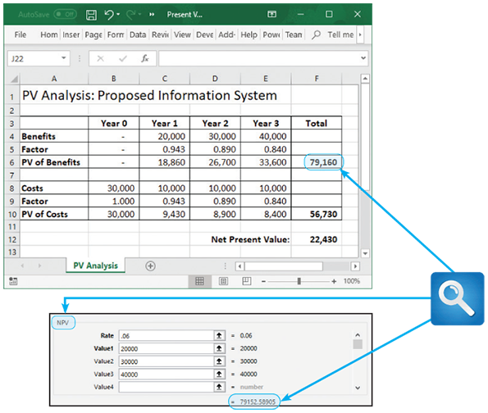

Using a Built-in Formula
The second method, which is shown in the bottom screen in Figure C-12, uses a built-in spreadsheet function to calculate present value. Enter the amounts, the discount rate, and number of time periods, and the program does the rest. Using this approach, four steps are performed, starting with the benefits.
- First, create a spreadsheet similar to the upper screen in Figure C-12, but do not enter any factors or formulas—just the year-by-year cost and benefit amounts.
- Next, select cell F6 and click the Function button on the formula bar. Select the NPV function, and a dialog box similar to the bottom of Figure C-12 appears. A discount rate of 6% is being used, so enter 0.06 in the Rate box.
- Now enter the three benefit amounts: 20,000 for Value1, 30,000 for Value2, and 40,000 for Value3, and click the OK button (not shown in the figure).
- At this point, a present value appears in cell F6. Now follow the same method to enter the cost amounts. When the PV of costs is subtracted from the PV of benefits, the result is the NPV. Note there is a slight difference in the two methods because Excel uses more decimal places. The difference is not significant.
Change font size
help
Main content

C.5Summary
A systems analyst must be concerned with economic feasibility throughout the SDLC and especially during the systems planning and systems analysis phases. When a project is reviewed, various feasibility and financial analysis tools are used. For example, in Chapter 2, it was explained that economic feasibility depends on a comparison of costs and benefits. A project is economically feasible if the future benefits outweigh the estimated costs of developing or acquiring the new system. In Chapter 7, it was explained that when development strategies are analyzed, financial analysis tools and techniques are used to examine various options. Then, as described in Chapter 12, these tools are again used to recognize the end of a system’s useful life.
Project costs are classified as tangible or intangible, direct or indirect, fixed or variable, and developmental or operational. Tangible costs are those that have a specific dollar value, whereas intangible costs involve items that are difficult to measure in dollar terms, such as employee dissatisfaction. Direct costs can be associated with a particular information system, while indirect costs refer to overhead expenses that cannot be allocated to a specific project. Fixed costs remain the same regardless of activity levels, while variable costs are affected by the degree of system activity. Developmental costs are onetime systems development expenses, while operational costs continue during the systems operation and use phase.
Every company must decide how to charge or allocate information systems costs with the chargeback method. Common chargeback approaches are no charge, a fixed charge, a variable charge based on resource usage, or a variable charge based on volume.
Some companies use a no charge approach because IT services benefit the overall organization. This method treats the IT group for accounting purposes as a cost center that offers services without charge. In contrast, if management imposes charges on other departments, the IT department is regarded as a profit center that sells services that otherwise would have to be purchased from outside the company.
System benefits must also be classified. Many benefit categories are similar to costs: tangible or intangible, fixed or variable, and direct or indirect. Benefits also can be classified as positive benefits that result in direct dollar savings or cost-avoidance benefits that allow the firm to avoid costs that they would otherwise have incurred.
Cost-benefit analysis involves three common approaches: payback analysis, ROI analysis, and present value analysis. Spreadsheet programs can be used to help work with those methods.
Payback analysis determines the time it takes for a system to pay for itself, which is called the payback period. In payback analysis, the total development and operating costs are compared to total benefits. The payback period is the point at which accumulated benefits equal accumulated costs. A disadvantage of this method is that payback analysis analyzes only costs and benefits incurred at the beginning of a system’s useful life.
ROI analysis measures a system by comparing total net benefits (the return) to total costs (the investment). The result is a percentage figure that represents a rate of return that the system offers as a potential investment. Many organizations set a minimum ROI that all projects must match or exceed and use ROI to rank several projects. Although ROI provides additional information compared with payback analysis, ROI expresses only an overall average rate of return that might not be accurate for a given time period. Also, ROI does not recognize the time value of money.
Present value analysis adjusts the value of future costs and benefits to account for the time value of money. By measuring all future costs and benefits in current dollars, systems can be compared more accurately and consistently. Present value analysis uses mathematical factors that can be derived or found in published tables. Spreadsheet functions can also be used to calculate present value. Many companies use present value analysis to evaluate and rank projects.
Change font size
help
Main content

Exercises

Questions
- How do you know if a project is economically feasible?
- Describe four cost classifications and include two examples.
- What are four chargeback methods?
- Describe each benefit classification and include two examples.
- What is the payback period?
- What formula do you use to calculate the payback period?
- What formula do you use to calculate ROI?
- Would the formulas in questions 6 and 7 also apply to heavy equipment, such as a bulldozer? Why or why not?
- Define the term present value and provide an example.
- What is the meaning of the phrase, time value of money?

Discussion Topics
- Why is it difficult to assign a dollar figure to an intangible cost? Can it ever be done? Explain your answer and provide an example.
- Discuss some of the pros and cons of the four chargeback methods.
- Discuss some of the pros and cons of payback analysis.
- In this Toolkit, you learned how to use payback analysis, ROI, and NPV to assess IT projects. Could these tools be used in your personal life? Give an example of how you might use each one to help you make a financial decision.
- The time value of money can be an important factor when analyzing a project’s NPV. Is the time value of money just as important in periods of low inflation as it is in periods of high inflation? Explain your answer.

Projects
- Explore the TCO calculator shown in Figure C-1 that Amazon.com provides for estimating value in migrating to the cloud using their AWS infrastructure for a hypothetical product. Comment on the usefulness of such a tool to the systems analyst.
- Prepare a presentation explaining the four chargeback methods.
- Assume the following facts:
  - A project will cost $45,000 to develop.
  - When the system becomes operational after a one-year development period, operational costs will be $9,000 during each year of the system’s five-year useful life.
  - The system will produce benefits of $30,000 in the first year of operation, and this figure will increase by a compound 10% each year.
What is the payback period for this project?
- Using the same facts as in Project 2, what is the ROI for this project?
- Suppose you are studying two hardware lease proposals. Option 1 costs $4,000 but requires that the entire amount be paid in advance. Option 2 costs $5,000, but the payments can be made $1,000 now and $1,000 per year for the next four years. If you do an NPV analysis assuming a 14% discount rate, which proposal is less expensive? What happens if you use an 8% rate?
Change font size
help

